**How to use the artifact:**

The artifact is based on Google Colab computing engine. To run a certain version of the artifact, you can follow below steps:

1. Sign-in to Google Colab using a google account
2. Upload all the dependent module to Google Colab “Files”

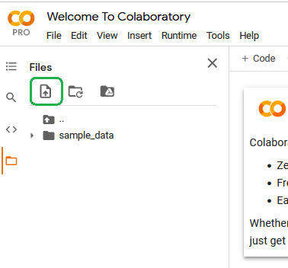

1. Open one of the artifact versions on Google Colab
2. Mount your google drive which contains a folder named “Colab Notebooks” and its subfolder named “SIT723”. Inside “SIT723” folder, you create 3 subfolders for each dataset, namely “FER2013”, “CKplus”, and “JAFFE”. Each subfolder should be the location where you save/store all the datasets according their categories.

For example, the training images and labels of FER2013 should look like:

“Colab Notebooks/SIT723/FER2013/x_train.csv”

“Colab Notebooks/SIT723/FER2013/y_train.csv”

1. Now, run the artifact in the top-down order to avoid missing any dependent python packages

**NOTE:**

The process of running the artifact may vary based on the internet speed, the fluctuation of GPU available, and the Google account type.